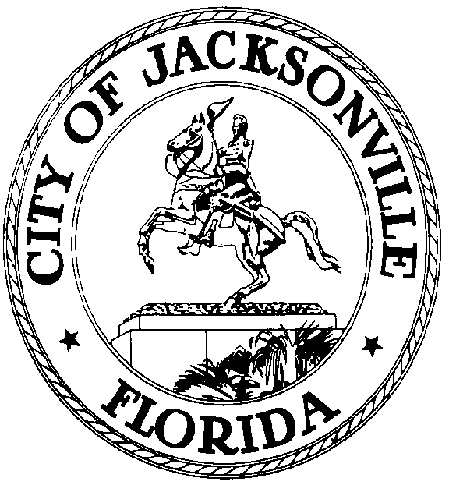

GARRETT L. DENNIS
Council Member District 9
E-Mail: GarrettD@coj.net

OFFICE OF THE CITY COUNCIL
117 West Duval Street City Hall, Suite 425
Jacksonville, Florida 32202
Office (904) 255-5209
Fax (904) 255-5230
.

MEDIA RELEASE

FOR IMMEDIATE RELEASE – October 2, 2020
Contact: Taryn Roberts (904) 255-5209

COUNCILMAN GARRETT DENNIS AND REPRESENTATIVE TRACIE DAVIS TO HOLD PRESS CONFERENCE RE: REGISTERED VOTERS

JACKSONVILLE, Fla. –
Who: Councilman Garrett Dennis and Representative Tracie Davis

What: Thousands in Jeopardy of Not Being Allowed to Vote in November

When: Friday, October 2, 2020
11:30 am

Where: Supervisor of Elections Office
105 East Monroe Street
Jacksonville, FL 32202

Why: Over 7,000 residents in Duval County have submitted voter registration applications and are not registered to vote. The goal is to raise the awareness of this issue by encouraging residents to check their registration TODAY with the Supervisor of Elections Office to be certain they’re eligible to vote.
###

